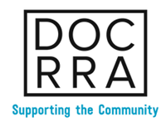

DOLPHIN COAST RESIDENTS & RATEPAYERS ASSOCIATION
(Non-Profit Company)
ANNUAL GENERAL MEETING
22 MAY 2019

AGENDA

- Opening & Welcome
- Approval of previous minutes
- Chairman’s Report
- Audited annual financial statements
- Feedback from special guests
  - Security cameras into the Ballito & Salt Rock areas
  - IPSS rescue efforts in Mozambique
- Special Resolution – Constitution
- Election of DOCRRA Committee Members
- General
- Close

